PYTHON

**print(“hello world”)** or **print(‘hello world’)** Print function

**print(“asd”,’asd’,sep=’2‘,end = ‘\n’)**

To take input **a = input()** by default it will be in string. To convert a string into a in to **a=int(input())**

**type(variable_name)** returns variable type

**var = 31**

**var = 3.22**

**var = True**//in C++ it should be **true**, in python **True**, same for false

**var = ‘err’**

**var = “err”**

**type(var)** // gives data type of var

**%** remainder function

**\*\*** exponent function

**//** integer division

**and or not** intersection, union, negation

**not condition** and **not(condition)** both are correct

**range** function

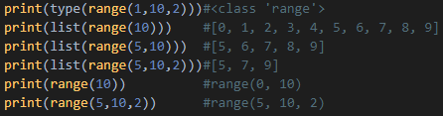

STRINGS

**X = “I am a string”**

**print(x + “hi“ + x)**// output is **I am a stringhiI am a string**

**print(x * 2)**// output is **I am a stringI am a string**

**X.capitalize()**//invert the cases, converts uppercase to lower and lower to upper

**Z = “zozozo”**

**print(Z.replace(‘zo’,’zil’))**//zilzilzil

**print(Z.replace(‘zo’,’zil’,2))** //zilzilzo

**name.strip()**

 output is 

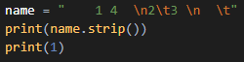 ouput is 

ARRAYS

**arr = [3,4,5]** //initialisation

**print(arr)** //[3, 4, 5]

**len(array_name)** //gives length of an array

array elements can be accessed by **arr[0]**, **arr[len(arr)-1]**

**print(type(arr))**//output is **<class ‘list’>**

unlike in C++, python arrays can have different data types

**arr=[1,”string”,False,True,[1,”again”]]**

C++ struct or class is similar to python lists. C++ arrays and vectors are not there in python.

**print([1,2]*2)**//**output is [1, 2, 1, 2]**

**print([1,2]+[3,4])** //**output is [1, 2, 3, 4]**

array addition and multiplication is similar to strings.

**arr.append(var)**//adds that element at last

**arr.pop()**//removes the last element

**arr.pop(number_of_that_element)**//removes the specified element and shifts all elements after that removed element to left

Slicing an array:

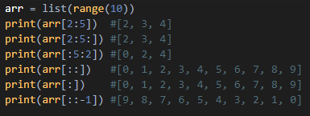

To reverse an array we can use an in-built function **arr.reverse()** or use **arr_new = arr[::-1]**

if & else & elif

to compare things we can use **>=**, **<=**, **==**, **!=** , **>**, **<**

**if(condition1 and condition2):**

**print(“some nonsense”)**

**else(condition3):**

**print(“again nonsense”)**

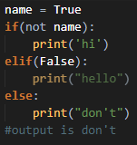

Loops

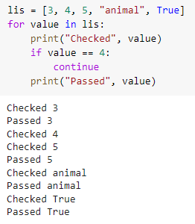

Maps

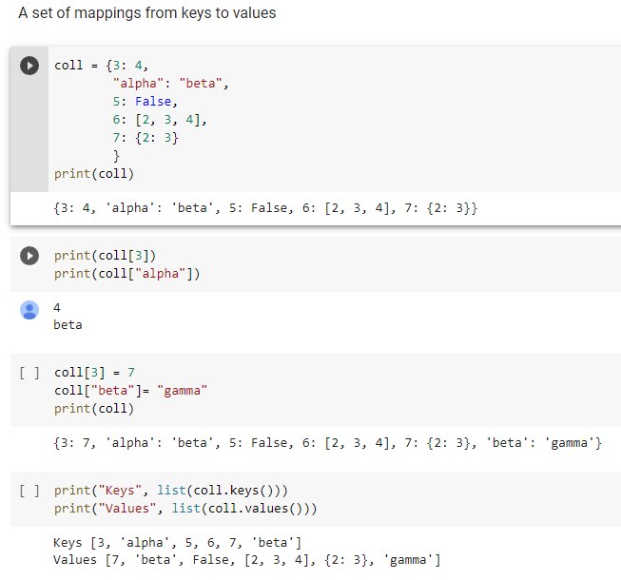

Functions

**def function_name(variable1,variable2):**

**variable = variable1 + variable2** //or some algorithm

**return variable**

if return variable is not there, in C++, there will be an error, but in python it will return **None** which is **NoneType** data type

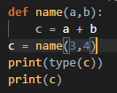

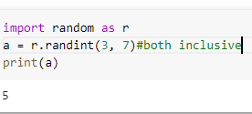 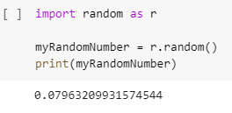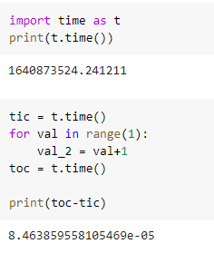

Edit Files by a Python Program

